**DAY 5 - TESTING, ERROR HANDLING, AND BACKEND INTEGRATION REFINEMENT**

# Responsiveness:

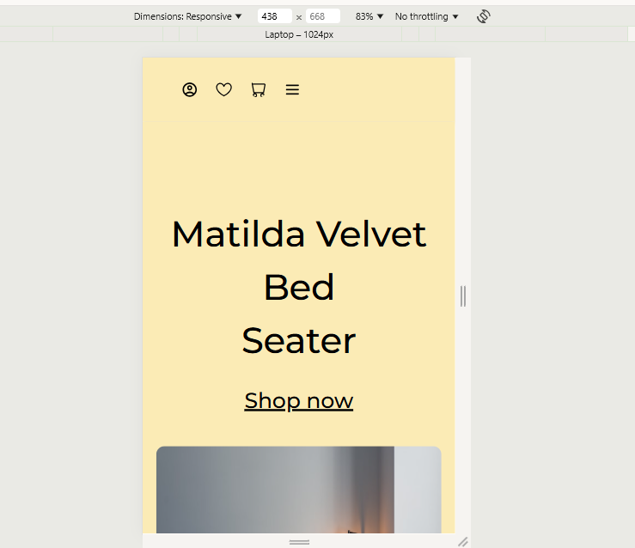

# Functionality:

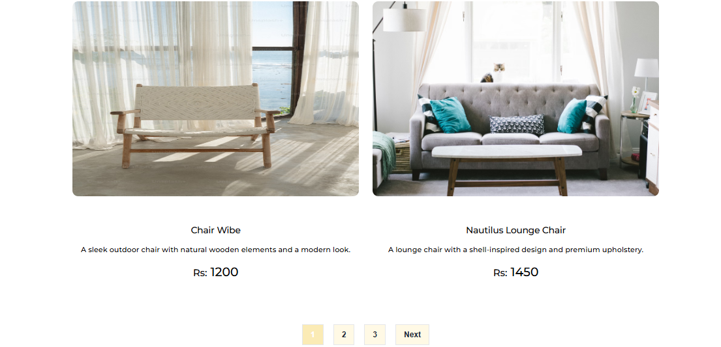

## Dynamic:

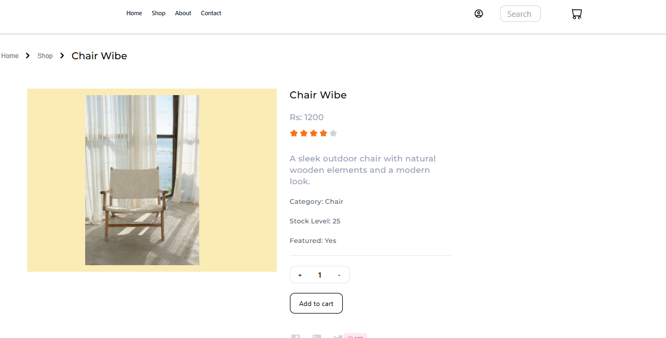

## Add to cart:

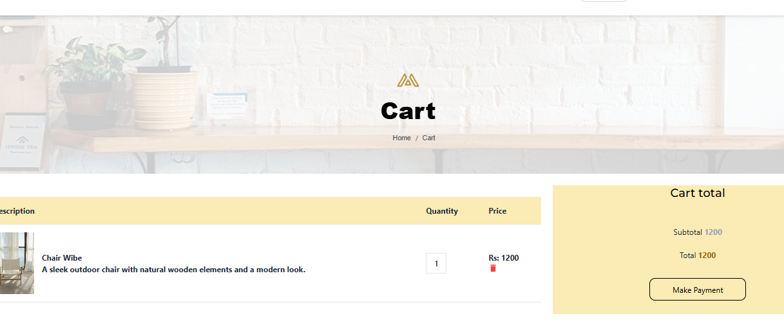

## Check out:

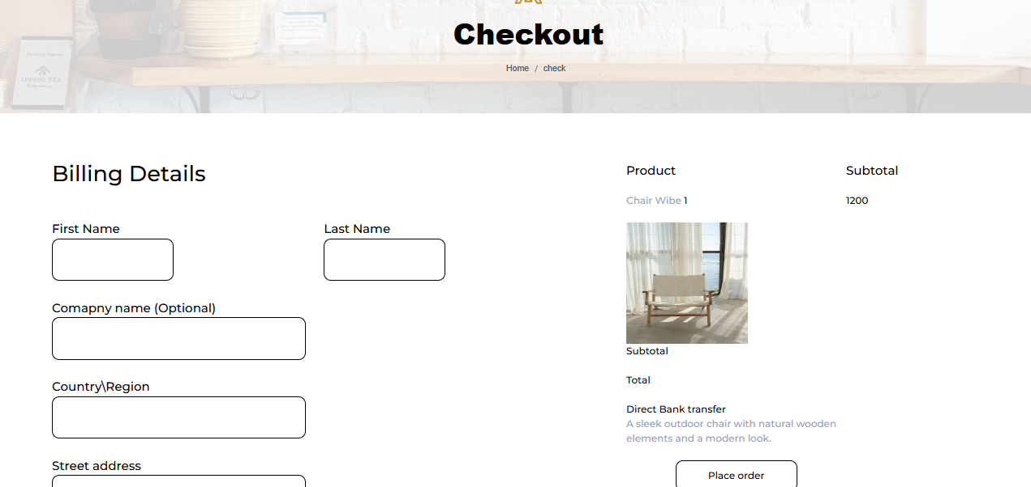

## Delete:

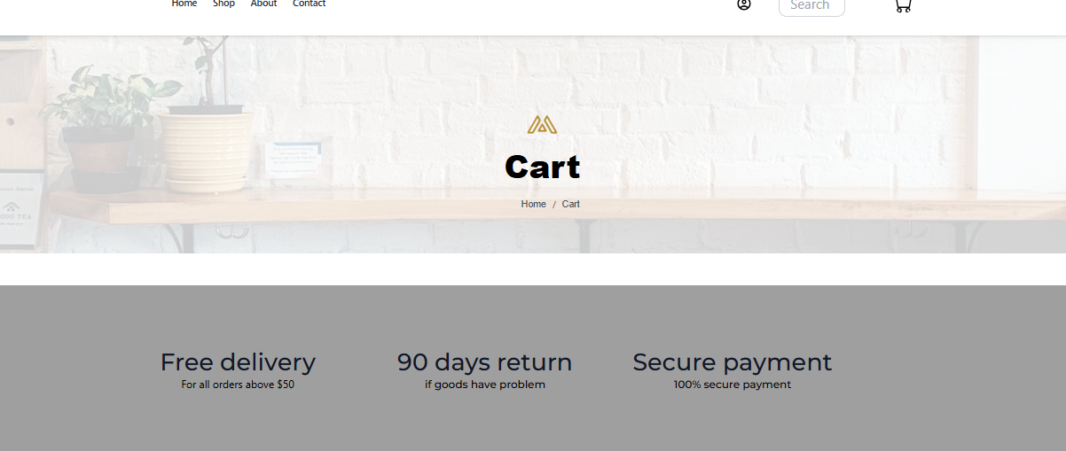

## Search:

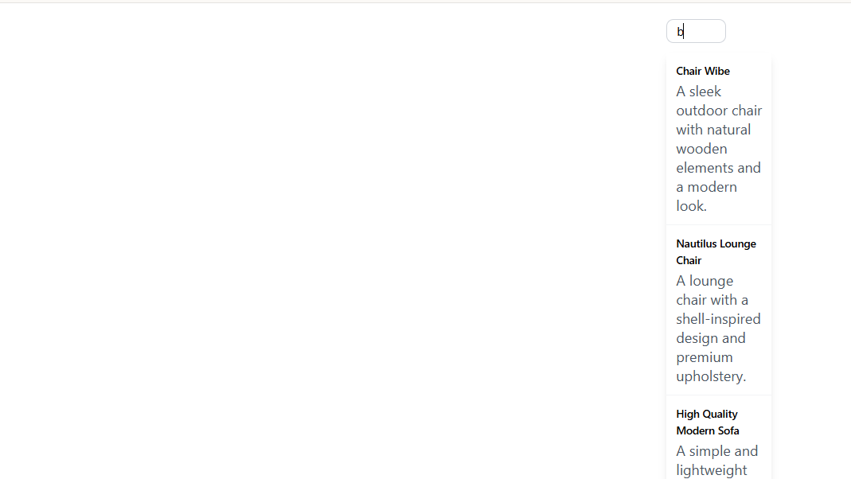



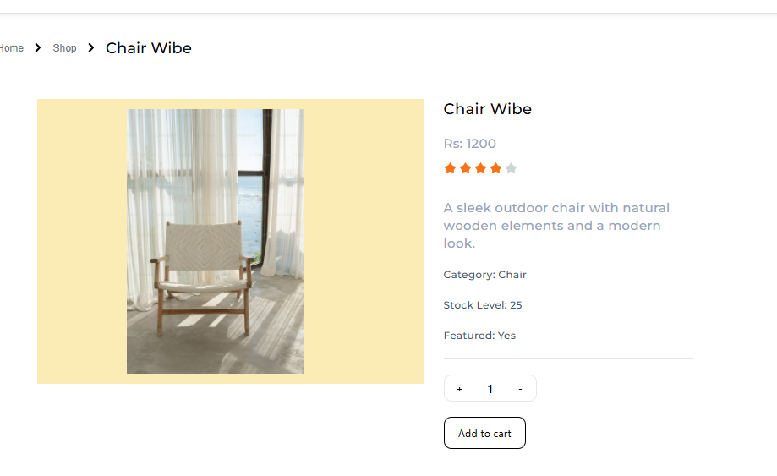

## Check API by Thunder API :

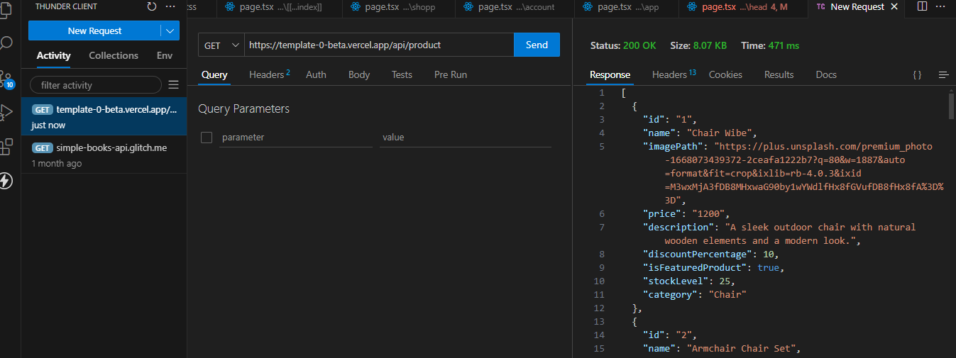

## Test :

| **Test Case ID** | **Test Case Description** | **Test Steps** | **Expected Result** | **Actual Result** | **Status** | **Severity Level** | **Assigned To** | **Remarks** |
| --- | --- | --- | --- | --- | --- | --- | --- | --- |
| 2 | TC001 | Validate product listing page | Open product page > Verify products | Products displayed correctly | Products displayed correctly | Passed | High | - | No issues found |
| 3 | TC002 | Test API error handling | Disconnect API > Refresh page | Show fallback UI with error message | Error message shown | Passed |  | - | Handled gracefully |
| 4 | TC003 | Check cart functionality | Add product to cart > Verify cart contents | Cart updates with added product | Cart updates as expected | Passed | High | - | Works as expected |
| 5 | TC004 | Ensure responsiveness on mobile | Resize browser window > Check layout | Layout adjusts properly to screen size | Responsive layout working as intended | Passed | Medium | - | Test successful |

## SEO :

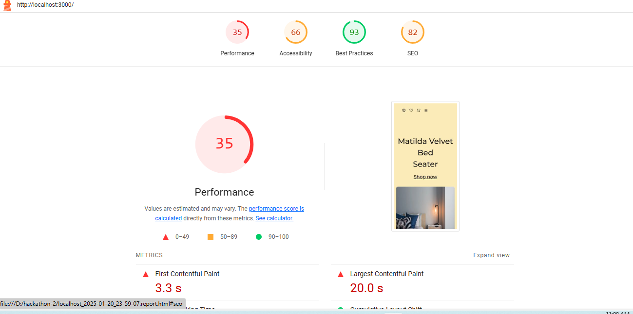

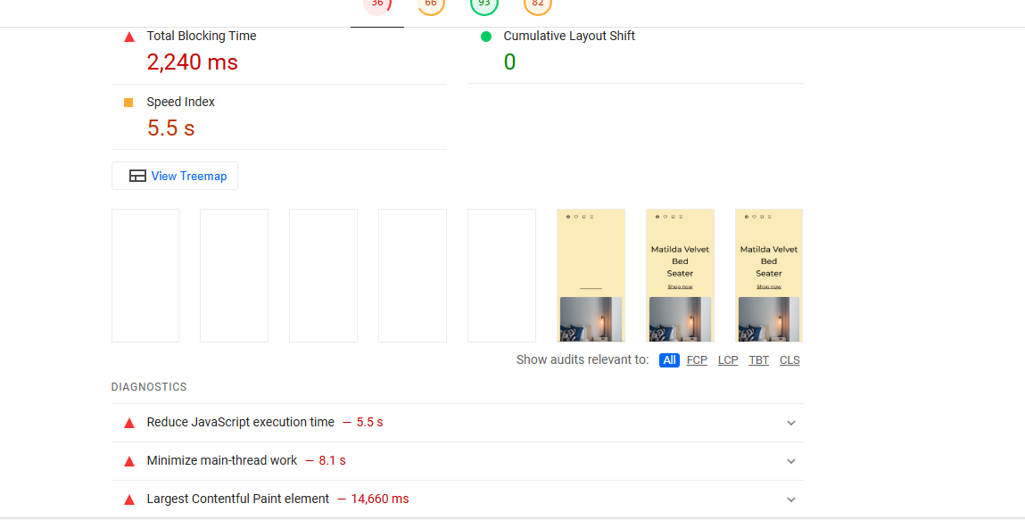

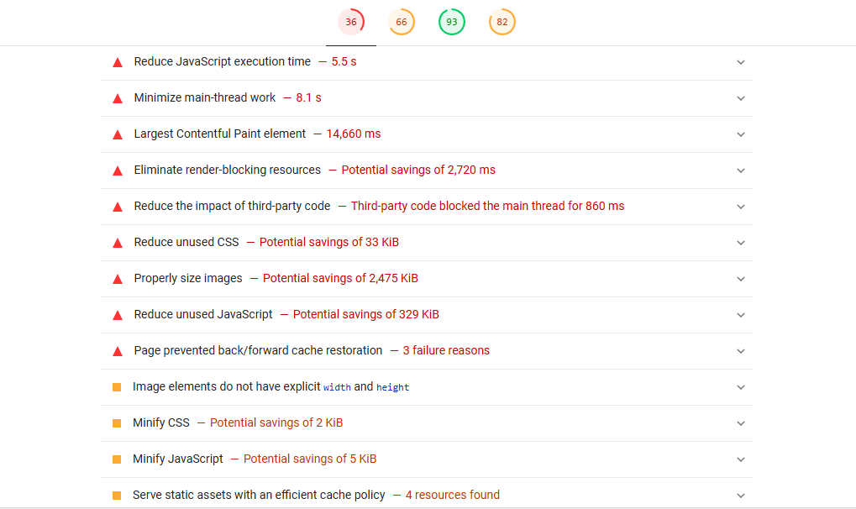

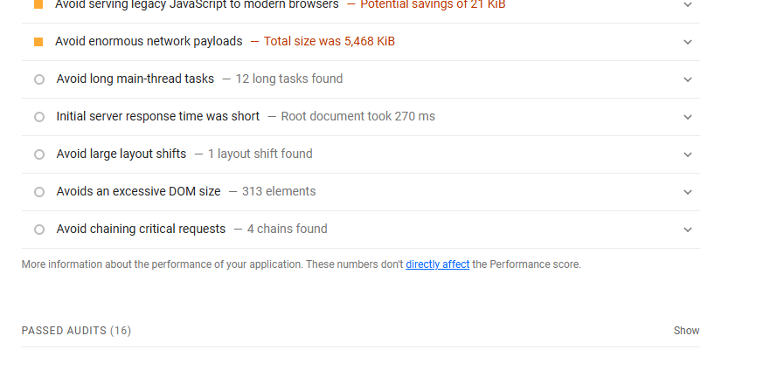

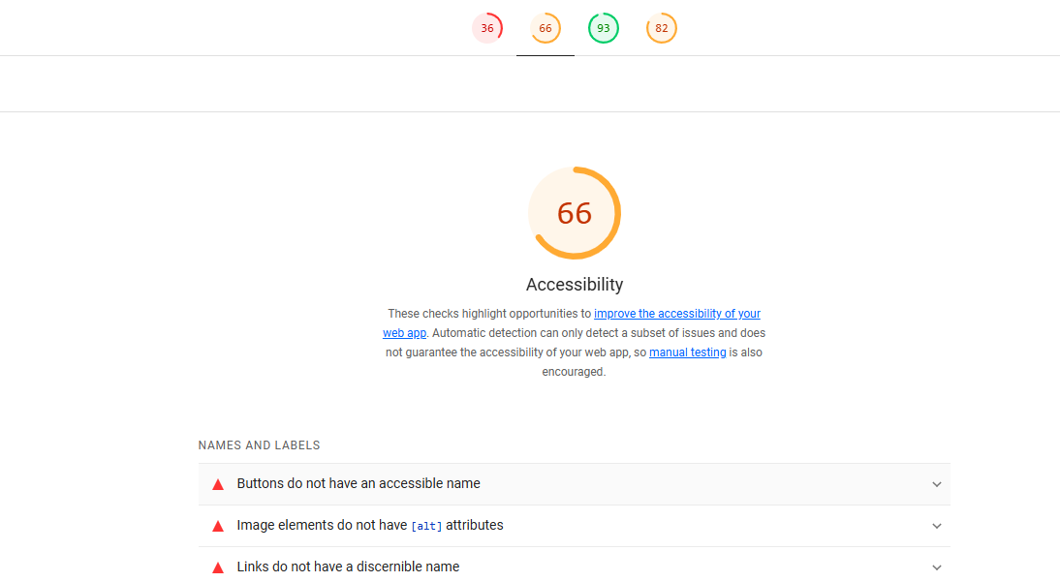

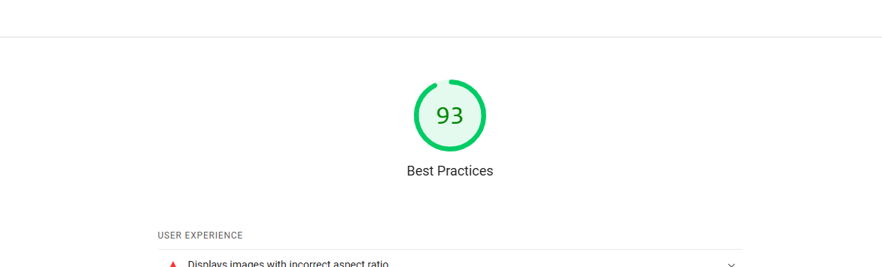

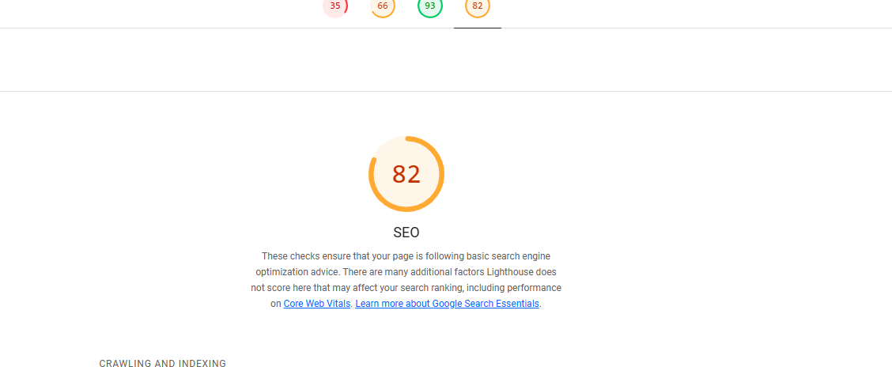

## Console:

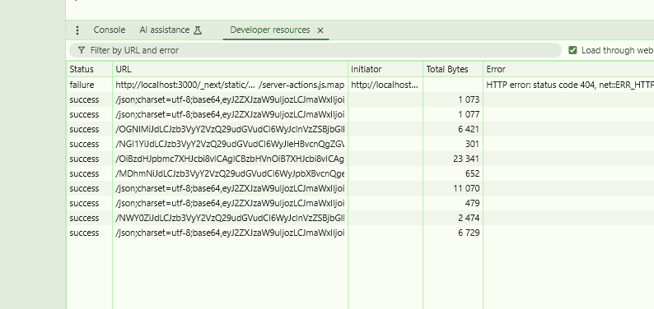

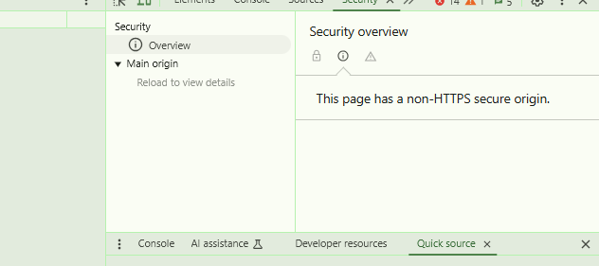

|  |
| --- |
| Name : Kinza Saeed  Roll : 00160400  Slot : 9 t0 12 |